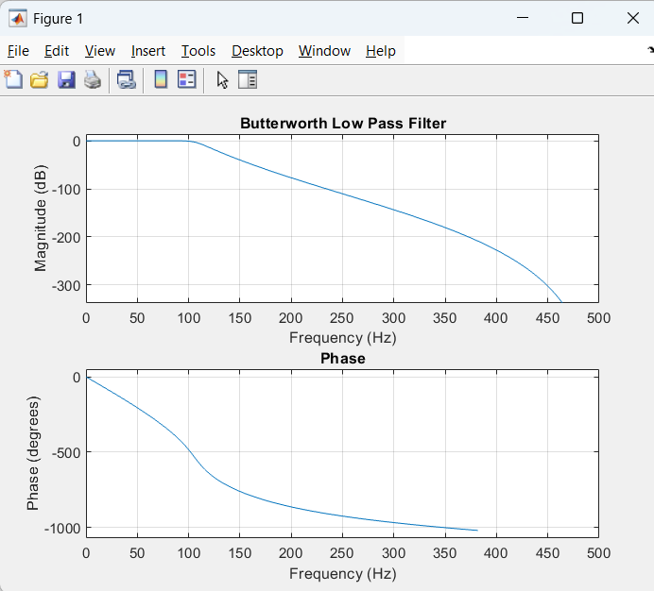

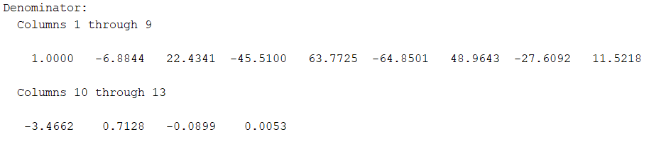

clc;
clear;
close all;
Fs = 1000;
Fp = 100;
Fst = 150;
Ap = 1;
Ast = 40;
Fn = Fs/2;
Wp = Fp/Fn;
Ws = Fst/Fn;
[n,Wn] = buttord(Wp,Ws,Ap,Ast);
[b,a] = butter(n,Wn,'low');
disp('Filter Order:');
disp(n);
disp('Numerator:');
disp(b);
disp('Denominator:');
disp(a);
figure;
freqz(b,a,1024,Fs);
title('Butterworth Low Pass Filter');

